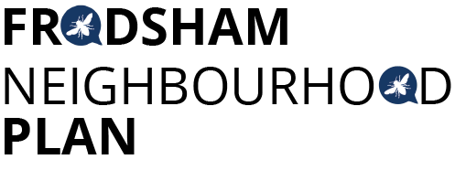
Steering Group Meeting - Tuesday 11th December 2018 at 1.30pm Castle Park House
Attendees:
Chris Burrows, Resident
Caroline Ashton, Resident FTC
Ashley McCraight, Resident
Martin Maris, Resident
Andrew Rowe, Resident
Peter Vickery, Resident
Gill Hesketh, Support and Admin, Resident
Apologies: Steve Carmody, Lynn Carmody.
The minutes of the last meeting were accepted. All actions were completed except GH & CV have not yet drafted the Twitter schedule for January
Frodsham Environment Report
MW had circulated a report written by the Mersey Forest, the Frodsham Environment Report, which is now in the public domain. This provides further evidence to support the developing policies of the FNP.
Six-week Consultation:
The LPA has confirmed a six-week consultation on the draft Plan must be undertaken. Rosie Morgan from the LPA confirmed;
“You need to do 6 weeks consultation before submitting to us. This needs to be wide ranging, involving the community, local businesses and landowners, anyone who may be affected by the plan. It also needs to include any relevant statutory bodies listed in schedule 1 of the regulations. You need to keep a record of all the consultation you have done to include in your consultation statement, which will form part of the formal submission to the council when you get to that stage.”
This information was discussed, and GH suggested that some expert advice was needed to help with this process: writing an appropriate questionnaire; marketing advice etc.
The Plan can bid for funding to pay for this support. The meeting agreed to research organisations that had expertise in this area, specifically with NPs.

Draft Policies:
Some updated draft policies had been sent to PV who has slotted them into the format. It was agreed that PV will collate the whole Plan ready for review at the first meeting in January.
AR raised a discussion about affordable housing and what evidence the Plan had about affordable housing needs in Frodsham. He will draft a policy for circulation and discussion.
AOB
FTC now have access to the free aerial photographs which will be useful in the final Plan.
The group had received an email from a member of the public asking if the Plan can get the Goods Shed listed. A response was drafted, GH to send to the individual.
MM has developed an e-Christmas card (based on a painting of Frodsham) for circulation to all our contacts.
AMcC informed the group that a local Active Travel Forum has been set up. The Forum would like to use the information from the first public meeting that FNP held and the Active Cheshire report. This was agreed by the group.
The meeting closed at 3.30pm.
Next meetings:
Monday 7th January 2019 at 6.30pm
Tuesday 22nd January 2019 at 1.30pm
Tuesday 29th January 2019 at 1.30pm
All at Castle Park House
Actions from this meeting:
ACTION | OUTCOME
- GH to respond to email re Goods Shed | Email sent 12/12/18
- GH to contact CCA re consultation, PV to contact his contacts | CCA contacted 12/12/18
- All to send drafts to PV for collation.
- GH to circulate e card | 13/12/18
- GH & CA to draft Twitter schedule for January

